Documenting a Telemedicine Consult
- Access your patients’ chart as you normally would. Make certain that the encounter has been changed to a Telehealth Appointment
- Go to Documentation tab to start your note
- Click on Add and choose Dynamic Documentation in the drop down
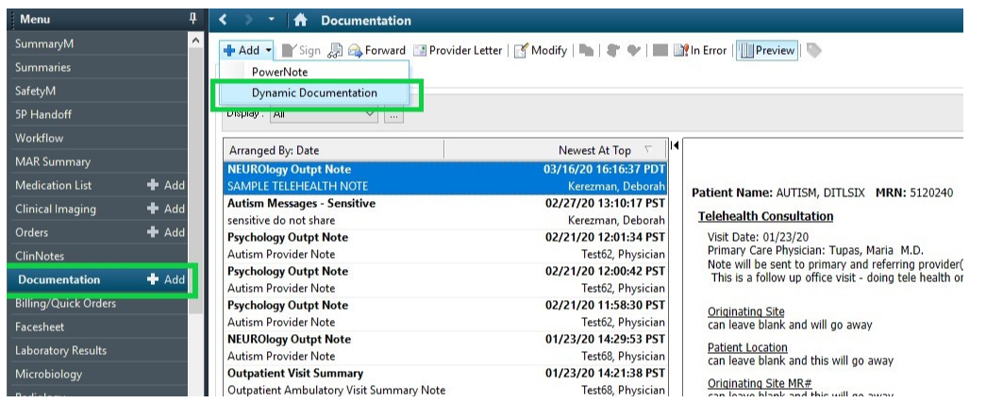
- Under Note Type, select your normal outpatient note type
- For template, select Telehealth Based note Template and click OK
- The Telehealth Template includes patient consent for a Telehealth Visit.
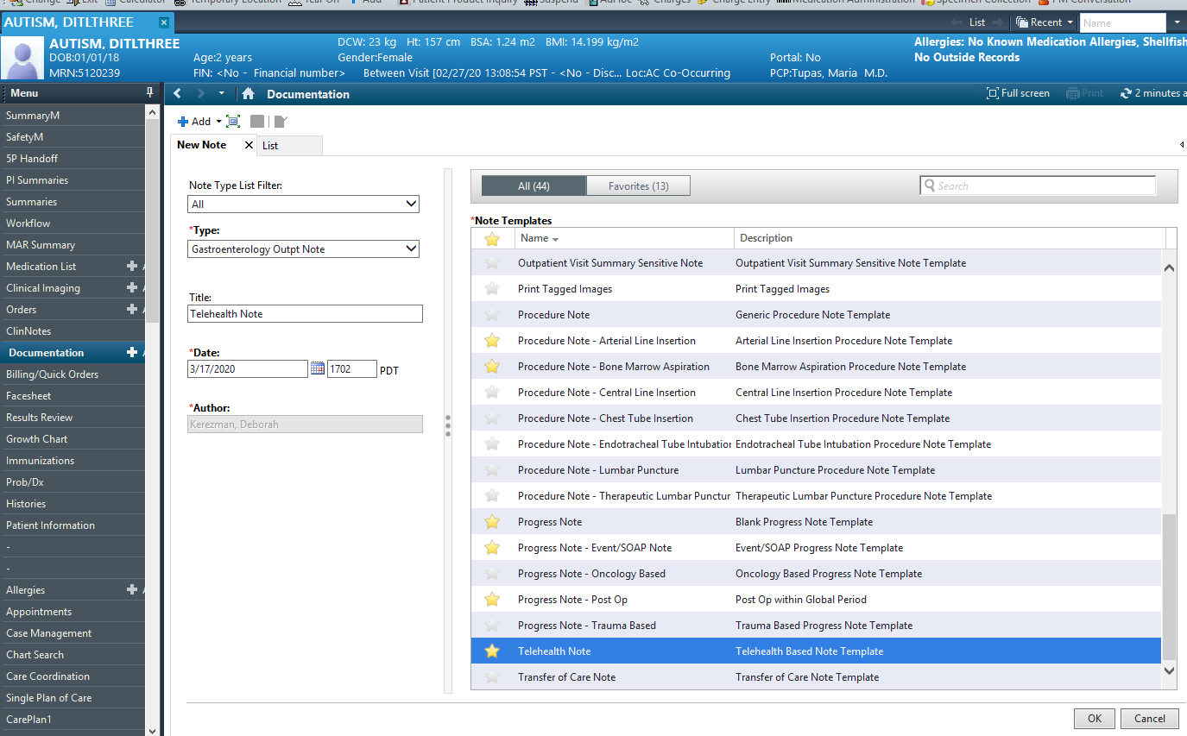

- Document Telehealth Visit findings. Areas left blank will disappear in final note.
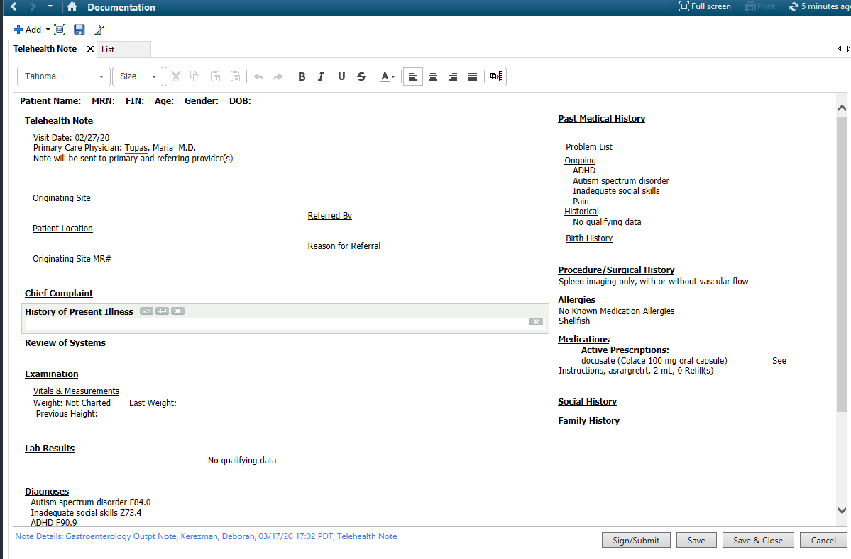
- Sign and Submit

*For providers who still wish to use PowerNote you will need two things:

- Telehealth billing is not incorporated into the note. Under Professional Services, select NO CHARGE and proceed to the Billing/Quick Orders page to drop charges (see next page) 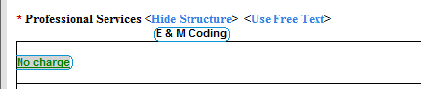
- Add the Telehealth Consent Statement to the bottom of the note with auto-text. Open Attestation, and use ``telehealth to incorporate the autotext.

Billing/Quick Orders
2
3

1
- Return to Clinic- select appropriate order for Return to Clinic or Return to Telehealth
- Telehealth Billing- Choose appropriate Billing Order
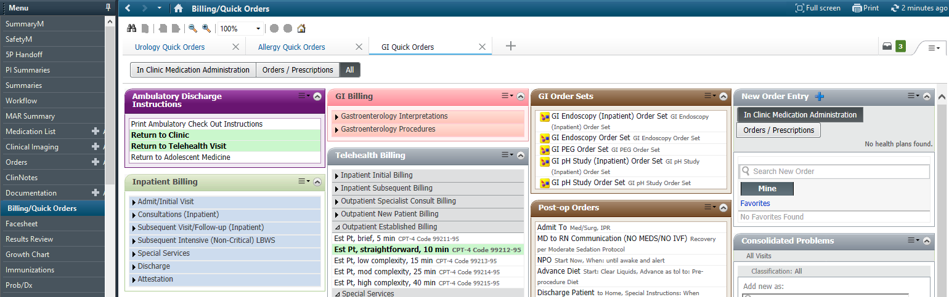
- Check out- Finish (modify) and Sign all selected orders

