Adding a Group Email to Your Inbox
- Add the From option to your email
  - Open a New Email
  - Select Options on the tool bar
  - Select the From icon
  - The From field will be added above To…
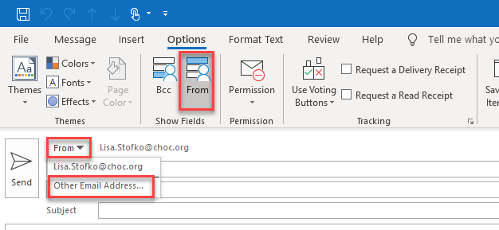

- Select the From icon to access a drop-down menu showing your name and the option of Other Email Address…
  - Select Other Email Address…
  - Enter the group email address (CHOCTelehealth@choc.org) in the window and select OK
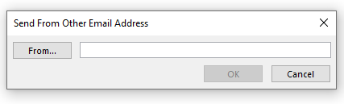
Type: CHOCTelehealth@choc.org

- Toggle between your email address or the group email address to send an email.
  - Select the group email address to send telehealth information to the patient
