Identifying Return to Telehealth Orders on the Request List
- Get into Preferences on the request list
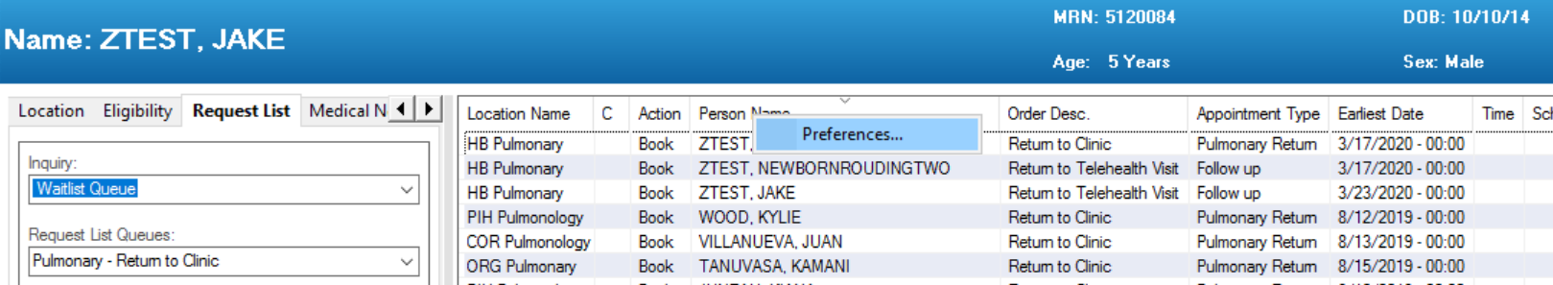

- A Column Preference window appears. Under the Selected Columns section, highlight Order Desc. and use the up and down arrows to raise Order Desc. closer to the top, like in the example below, Click Ok to save changes:
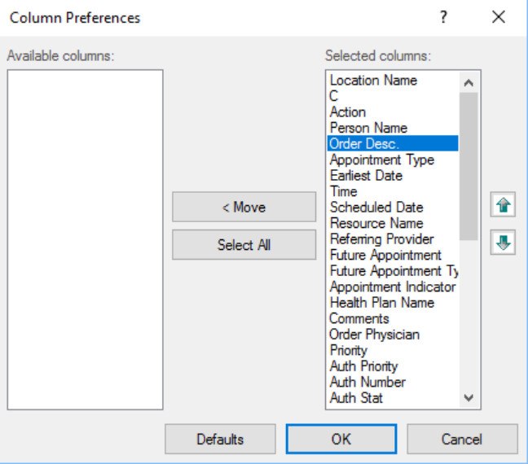

- Use the Order Desc. column to identify which order needs to scheduled for a Telehealth appointment type.
