Telehealth Appointment Documentation
Dynamic Documentation Users

- Documenting a Telemedicine Visit

- Access the patient’s chart via Ambulatory Organizer. The Details column indicates which appointments are Telehealth:
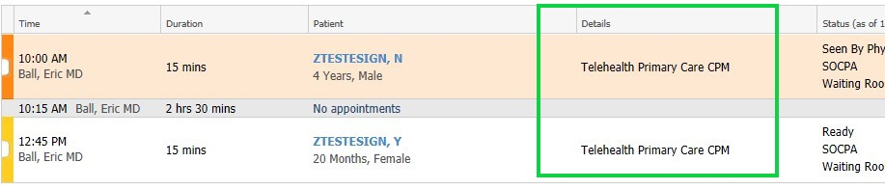
- When you are ready to document, choose your note and template type from the Documentation tab of your menu. Feel free to save the template as a favorite by clicking the star on the left:
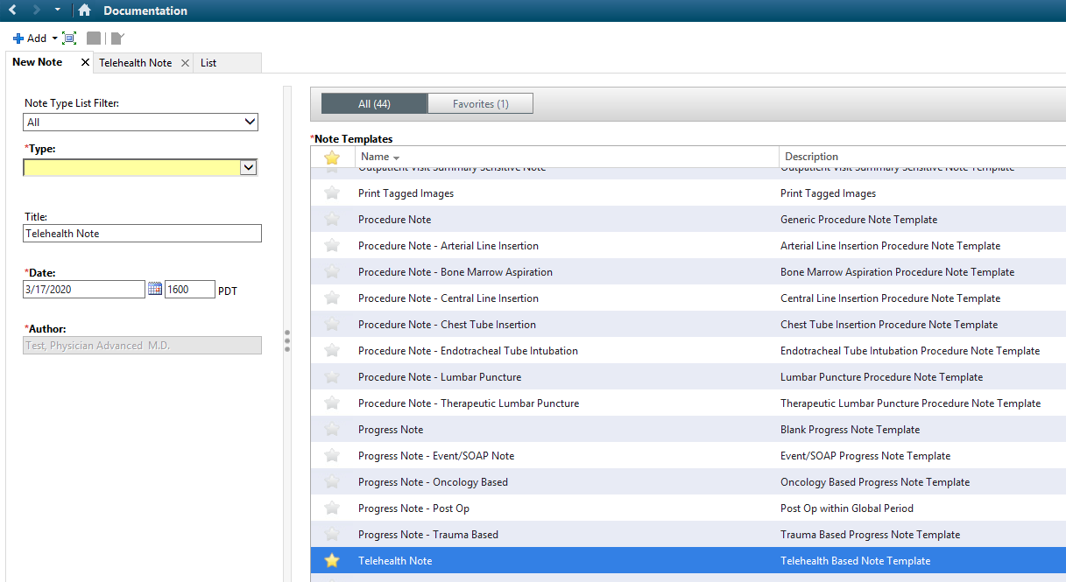
*Primary Care Network users can find a link to a Sick Note- Telehealth at the bottom of the workflow along with the other notes to select*

- Please note the fields unique to the Telemedicine template:
  - Like other Dyn Doc fields that are empty, they will disappear once signed if there is no content
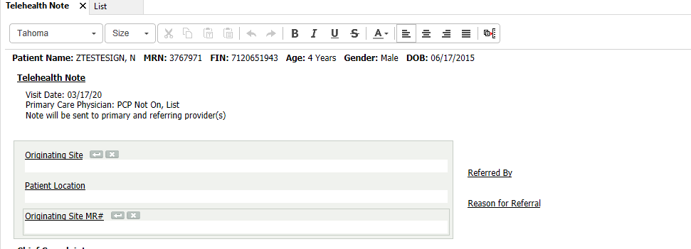
  - The bottom of the note includes a mandatory consent statement:
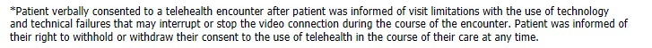
d) Document in your note and click sign when finished.
- Billing & Follow-Up Orders

On the Quick Orders page, there is a new Telehealth Billing component where you can drop your visit charges, as well as a Return to Telehealth order for future appointments:

