Creating a Telehealth Instant Video Session
Examples of when to use:
- The patient does not have an email to receive the telehealth information
- Staff does not have an assigned CHOC email address to send telehealth information on behalf of choctelehealth@choc.org
- If parent/guardian is struggling to understand the instructions of receiving the information via email.
- If parent/guardian cannot read or primary language is other than English
Script for clinical staff offering a telehealth session for a patient while on the phone:
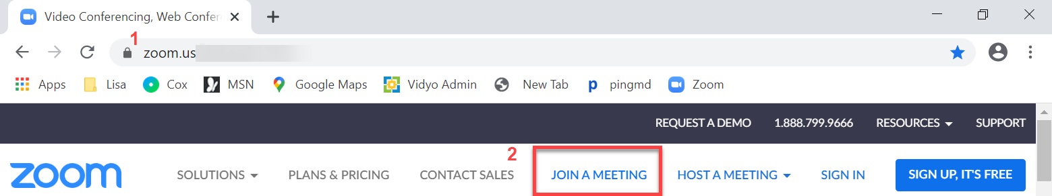
- At the time of the appointment, you will go to the internet (browser, such as Google, Chrome, Safari, etc.) and type Zoom.us in the address bar (the area on the top of the internet page.
- Once on the Zoom website, select Join a Meeting
- Enter the Meeting ID number (10 numbers) I provided you
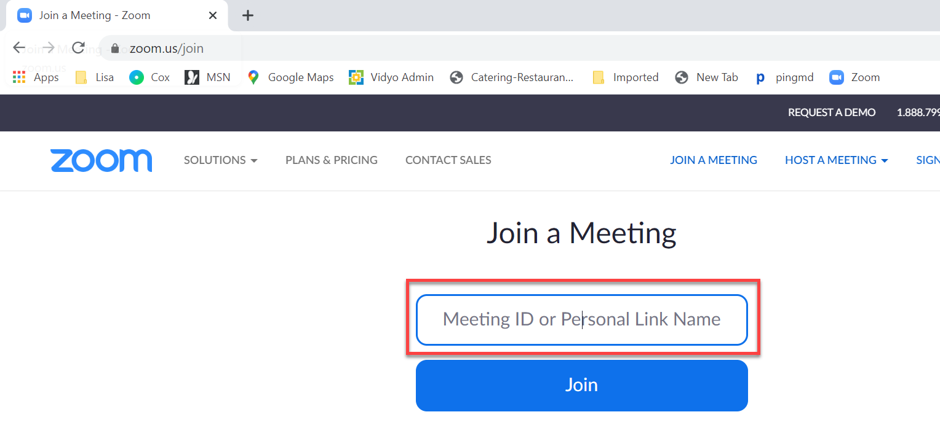
- Select Join

- If the physician has not joined the meeting you get a message to wait for the host to start the meeting.
  - If the physician has joined, you will be placed in a (virtual) waiting room, and the physician will admit you when ready to start video session.

