Outpatient Telehealth Scheduling, Registration and Check-in

- Launch Cerner Scheduling Appointment Book.
- Select Appointment tab and in the Appointment Type field enter “Telehealth”
  - Click the Ellipsis button to search.
  - Appointment Type Help screen appears. Select the appropriate appointment type.
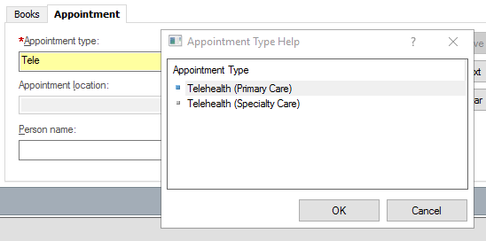
- Complete the remaining Appointment Type questions.
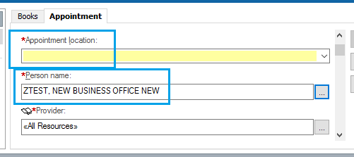
- Left click on Move to continue and the patient appears in the Work In Progress.
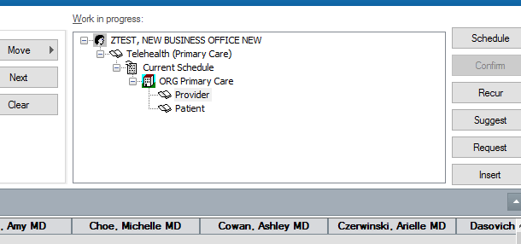
- Schedule the patient for the appointment using Drag-N-Drop or Suggest method. The patient and appointment display under the selected resource on the schedule.

- Click Confirm.
  - Confirm window launches. Click OK to save the appointment.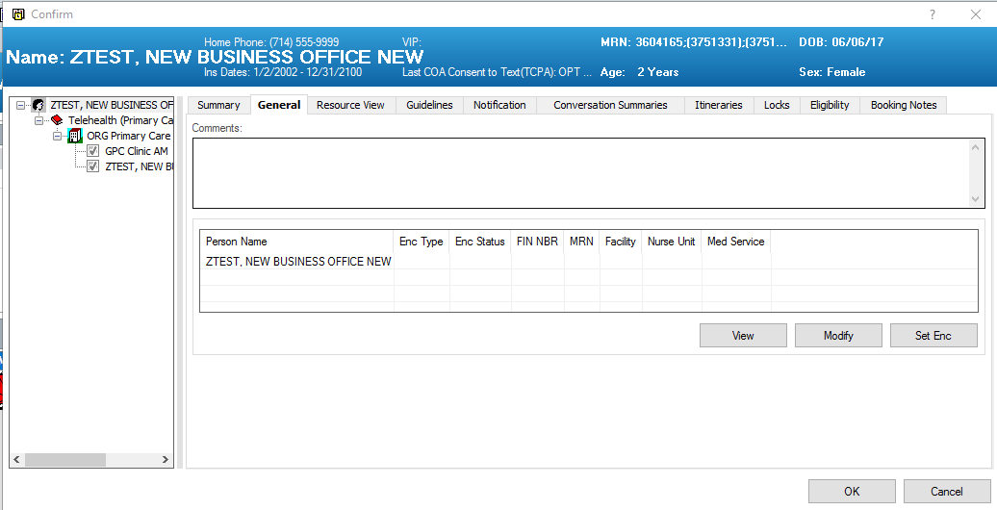
Adding an Encounter at the time of Confirm
- Select Set Enc to create an encounter for the patients visit. The PRE-Registration Outpatient conversation launches.
  - Encounter type initial defaults to PreRegister Outpatient.
  - For Telehealth patients you MUST change the encounter type to PreReg Op Telehealth.
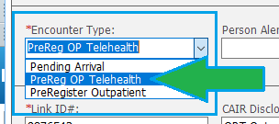
  - On the Visit tab the Expected Encounter Type = Outpatient Telehealth
  - Complete all registration data and save the conversation.
Check in Process for Patient
- Location the patient, right click and select Check In. The Check in window appears.
  - Appointment Type = Telehealth
  - Encounter Type = PreReg Op Telehealth
  - Select Modify to launch the conversation
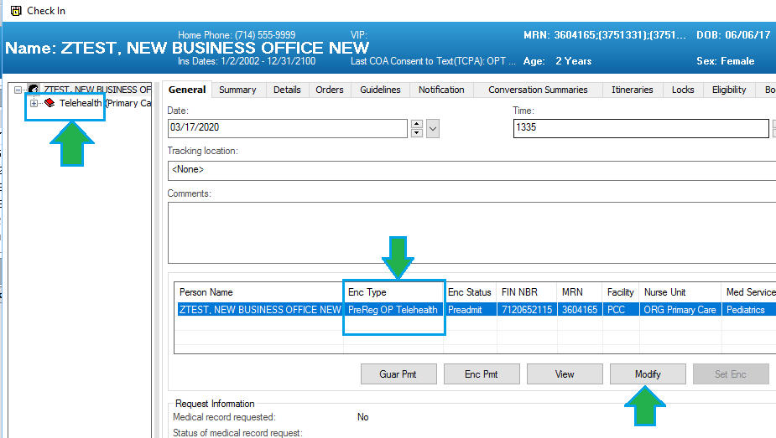
- Registration conversation launches. Select encounter type Outpatient Telehealth and complete all registration data and save the conversation.
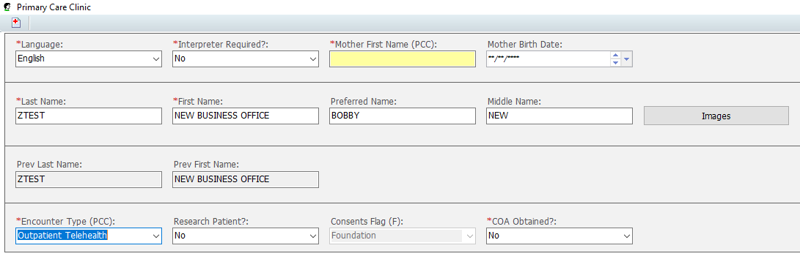
- Patient and Appointment status displays as Checked In.

Converting Appointment to Outpatient Telehealth

If the patient has an existing appointment, you must cancel the future visit and create a new appointment for Telehealth.

- Location the patient on the schedule. Right click and navigate to the Action Menu.
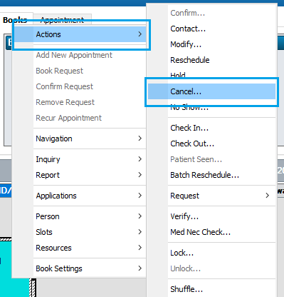
- Cancel window appears. In the Cancel Reason menu select Alternative Appointment Scheduled.
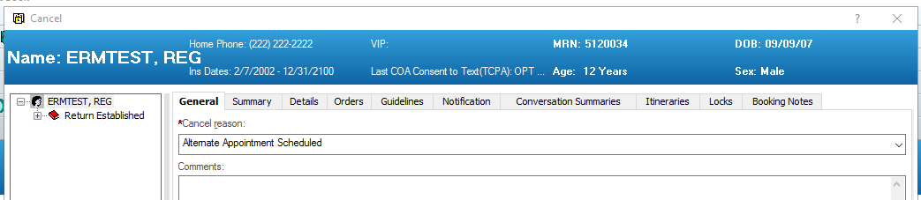
- Next navigate to the Appointment tab and in the Appointment Type field enter “Telehealth”.
  - Click the Ellipsis button to search.
  - Appointment Type Help screen appears, and results are returned.
  - Select the appropriate appointment type.
- Follow workflow and process to schedule and Pre Register the patient as Telehealth.

